**2.IDEATION PHASE:**

**2.1 Problem statement:**

| Date | 18 June 2025 |
| --- | --- |
| Team ID | LTVIP2025TMID47771 |
| Project Name | Visualization Tool For Electric Vehicle Charge And Range Analysis |
| Maximum Marks | 2 Marks |

**Customer Problem Statement Template:**

Electric vehicle (EV) users, fleet managers, and potential buyers often face uncertainty regarding battery charge levels, range estimation, and efficient route planning. Current EV dashboards and mobile applications typically offer only basic numeric data without visual clarity, lacking historical trends, predictive analytics, and personalized usage patterns.

As a result, users experience range anxiety, inefficient trip planning, and difficulties in understanding how various factors like terrain, speed, and weather influence battery consumption. Furthermore, infrastructure planners and analysts struggle to identify charging station demand due to insufficient visualization tools.

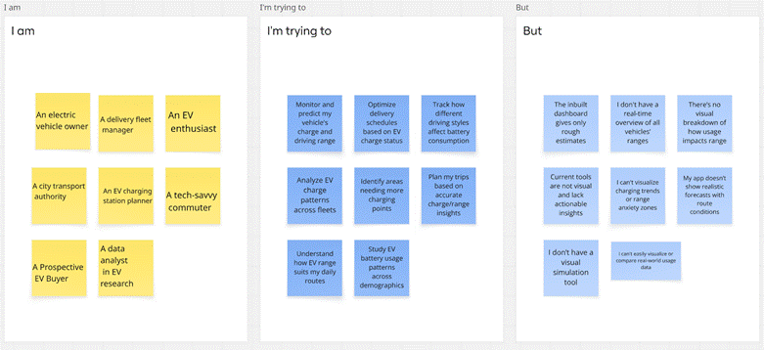

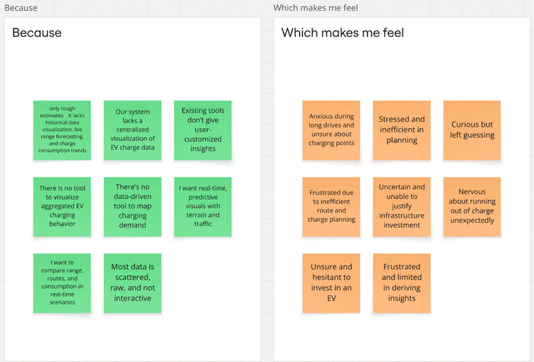**Example:**

